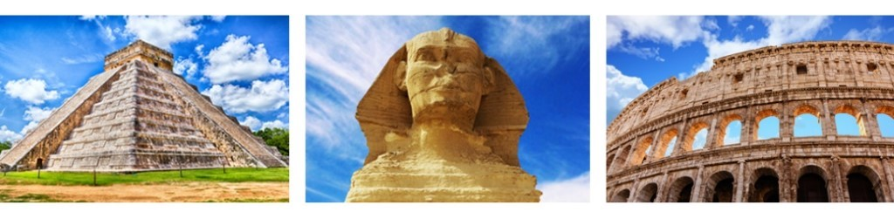
Lab: Virtual Archaeology
Created by Emily Bartz, Anthropology PhD Student
Name: ___________________________________________ Date: ___________________
For this lab you will experiment with some different facets of virtual archaeology. Virtual Reality (VR) allows individuals to experience archaeological sites and individual artifacts from around the world using 3-D simulation, often from the comfort of their own homes.
Part One: SketchFab (sketchfab.com)
1. Click on either of these models of houses from the famous Neolithic site of Skara Brae in the Orkney Islands, Scotland, excavated by V. Gordon Childe.
House 1
House 2
Move the cursor to rotate the point of view around. Click on the numbers embedded within the image to learn more about the individual house features or histories.
How does this experience compare to viewing photographs of the houses? __________________
______________________________________________________________________________
How do you get a better sense of these as “pit houses” or semi-subterranean compared to photos?
______________________________________________________________________________
How do you think this enhanced viewing compares to actually visiting the site (and you can’t go into the houses when you’re there)? _______________________________________________
____________________________________________________________________________
2. Stonehenge is a popular site for modelers to recreate. Click on all three models to compare. Zoom in and out, move the cursor for different views, and click on the embedded numbers.
Stonehenge 1 (the stone circle in its current ruined shape)
Stonehenge 2 (the stone circle, reconstructed as it might have appeared, inside the henge)
Stonehenge 3 (the Stonehenge landscape as determined by LiDAR; Stonehenge is #1)
Which one do you like the best and why? What are the pros and cons? ___________________
____________________________________________________________________________
Do you get a sense of the scale of the monument and landscape from these models? Why or why not? _________________________________________________________________________
Why is it important to have these three (and more) VR models of Stonehenge? ______________
______________________________________________________________________________
What did you learn that was unknown or unexpected about Stonehenge by visually manipulating these models? __________________________________________________________________
______________________________________________________________________________
3. Find your (or another) UNESCO World Cultural Heritage site, on Sketchfab or CyArk.
CyArk.org is dedicated to preserving heritage sites through 3D documentation.
Which site? (If not your chosen site, some other site of interest): ________________________
Did viewing the computer model help you better visualize or learn about your site, compared to just doing library research on it? Explain ___________________________________________
_____________________________________________________________________________
_____________________________________________________________________________

Part Two: Immersive experiences with VR headsets
______________________________________________________________________________

Watch the video: Students 'Visit' Lost Archaeological Site in Virtual Reality (4:24)
Using VR headsets, the experience of visiting an Assyrian Palace at ancient Nimrud, Iraq, destroyed by ISIS fighters, is recreated.
Watch the video: Virtual reality allows visitors see ancient Rome palace (5:03)
In this video tourists at the imperial Roman Domus Aurea, now underground and in ruins, can experience the palace as it once existed, at ground level with

Explain the additional value of an immersive virtual visit, compared with watching 3D manipulation on a screen: ________________________________________________________
_____________________________________________________________________________
From these examples, discuss how the use of VR headsets may help “replace” archaeological sites that are now destroyed or too remote or dangerous to physically visit. _________________
______________________________________________________________________________
______________________________________________________________________________
_____________________________________________________________________________
How else might VR technology change archaeology now and in the future? _______________
____________________________________________________________________________
____________________________________________________________________________

